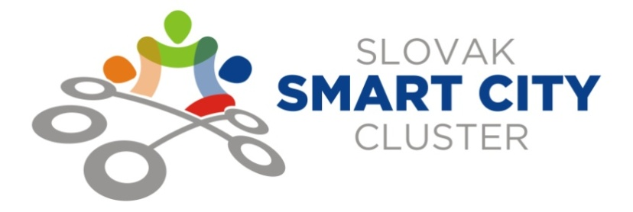
MEMBERSHIP APPLICATION
in the association of corporations
SLOVAK SMART CITY CLUSTER
APPLICANT´S INFORMATION
Corporate name:
Registered place:
Administrator/ director:
IČO:
IČ DPH:
Entered in register:
Contacts
(phone number, e-mail):

(next only „applicant “)
The applicant volunteer applies for the membership in the association of corporations (next only „association“)
SLOVAK SMART CITY CLUSTER
The applicant acknowledges that he has understood and agreed to the terms and conditions of Association Statements and If this membership application is accepted to follow the member duties and responsibilities.
The applicant attaches an extract from the Register of Entrepreneurs. /not older than 3 months/

In ............................. , date....................

.................................................................
Trade mark of applicant
First name, surname and position
of entitled person

